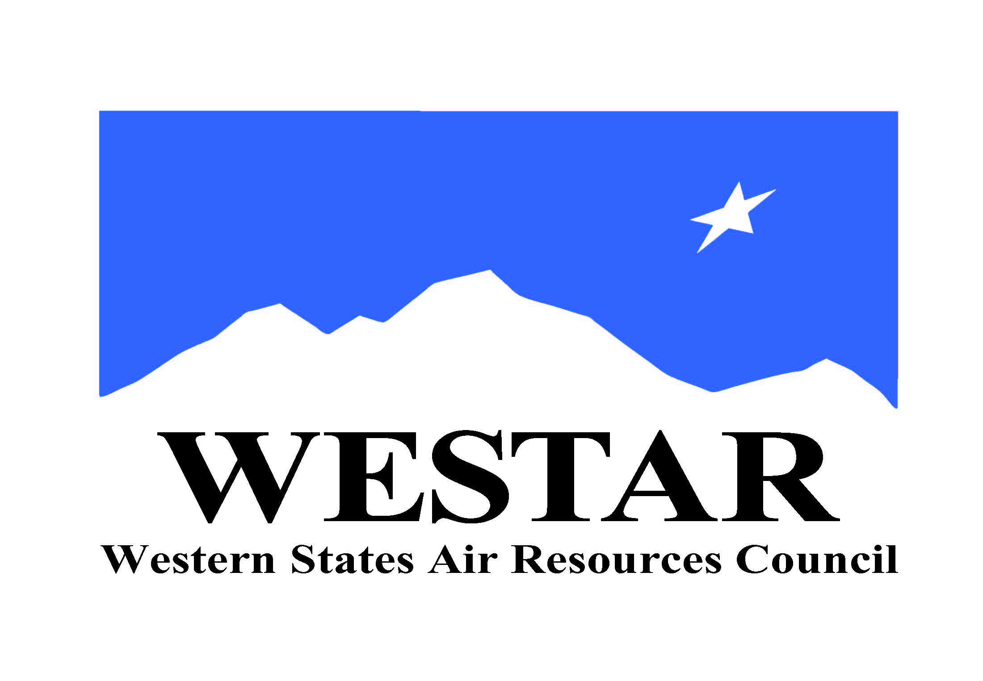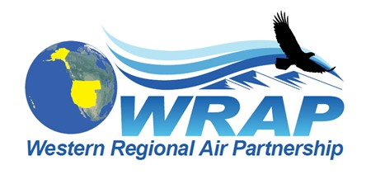
WRAP Work Topic Areas – Board approval December 2, 2020 – changes/updates of Dec. 1, 2021

Topic / WRAP “home” | Dec. 2020 Board-approved Project/Task (renumbered into each WRAP “home”, propose to remove some elements shown as strikethrough) | December 2021 update
Fire and Smoke Emissions and Impacts  /  Fire & Smoke WG | - Identify all the smoke management plans (SMPs) in the region and compare them (e.g. decision making process, rules, activity, seasonality)  - Create a site for tracking regional burn decisions in near real-time that lists info on decisions and completed burns from fire agencies  - Research and develop data needs and sources, emission inventory approaches, and evaluate remote sensing products  - Wildfire data (monitoring, modeling, emissions, etc.)  - Coordinate on wildland prescribed fire and smoke management programs | - FSWG Workplan Scope adopted January 26, 2021 – defines mission statement, membership, and goals  - Regular meetings underway  - 5 Subcommittee Teams identified, addressing projects/tasks in workplan scope  - Exceptional Events team underway  - Implementation of Conceptual Model for Fire Data project findings will require dedicated ongoing funding, NASA funding proposal submitted June 30, 2021. Stakeholder workshop held.
Oil & Gas Emissions Tracking and Analysis  /  Oil & Gas WG | - Extend period of performance for Ramboll contract to allow for items such as state specific assistance  - Annual compilation of agency program review to capture regulatory changes  - Assess and improve 2017 NEI O&G emissions estimates for IWDW-WAQS western regional modeling | - OGWG workplan scope final draft  - Resources not available at this point in time for contractor support to accomplish items 1 and 3  - Plan for Tri-Annual Work Group calls  - Subcommittee Teams to meet regularly to address topics in workplan scope  - Contract analysis support for EPA 2016v2 EI review and proposed EPA O&G Tool updates
Regional emissions and air quality analysis  /  Regional Technical Operations WG | - Conduct an ozone source apportionment modeling run using CAMx APCA (Anthropogenic Precursor Culpability Assessment) diagnostic tool to apportion source categories and states contributing to regional ozone transport and international contributions  - Build and evaluate base year model performance for 2017 IWDW-WAQS western regional modeling platform  - Identify Emission Inventory development needs and refinements, both anthropogenic and natural (such as Biogenic Emissions Inventory Improvements) | - RTOWG workplan scope final draft  - Plan for quarterly calls  - Resources not available at this point for contractor support to accomplish item 1  - Work on Item 2 complete, limited to 2017 meteorological and model boundary conditions modeling, end of 2017 modeling work  - Workplan scope identifies efforts by member agencies and plans for a more current year (2020/2021) modeling platform development through IWDW-WAQS  - Substantial funding for IWDW-WAQS funded contractor support not available until 2023
Regional Haze SIP Completion and Implementation  /  Regional Haze Planning Work Group | - Ongoing Regional Haze planning support from WESTAR-WRAP staff | - Tom Moore and Jay Baker to help with #1  - RHPWG workplan scope drafted and under review  - Plan for quarterly calls
WRAP Tribal Member Support  /  Tribal Data Work Group | - Technical assistance for tribes with state SIP (or related) reviews | - Limited ITEP resources available for any tribe needing help with #1 (first-come, first-served)  - TDWG workplan scope drafted and under review  - Plan for quarterly calls
WESTAR/WRAP-wide studies  /  WRAP staff | - Apply remote sensing data for air quality forecasting, for air quality management, and to public health decisions  - Implement projects proposed to NASA when/if funded  - Applying Advanced Earth Science Data for Aiding Air Quality Forecasting and Management Decisions  - Applying Earth Science Data to Air Quality Management and Public Health Decisions  3) 2) Assess regional resources to support emerging topics and needs  - Small sensors / alternative monitoring technologies  - Air toxics monitoring  - Fenceline monitoring  - Environmental justice initiatives  - GHG/other inventories | - In June, WESTAR-WRAP submitted as the lead or was part of 3 NASA ROSES funding proposals  - Wildland Fire Emissions Data Warehouse (WFEDW, led by WESTAR-WRAP)  - Organizing Remote Sensing Science Data for a Purpose: Decision Support Systems for Air Quality Management Applications (co-led by Univ. of Alabama Huntsville and WESTAR-WRAP)  - Western Initiative for State relevant Air Research for Decision making (WISARD, led by Univ. of Washington)  - If any of these are funded, work would start in early 2022 and utilize in-kind oversight and participation by Technical Steering Committee, WRAP Work Groups, and WESTAR Planning and Technical Committees  - For #2a, WESTAR intends to start a Technical Committee subgroup.  - No progress yet on 2b-e.

