# WHITE PAPER

# Potential Procedures for Making 2028 Visibility

# Projections using the WRAP 2014 Modeling Platform

March 24, 2020

**INTRODUCTION**

The Western Regional Air Partnership (WRAP) has developed a 2014 Photochemical Grid Model (PGM) modeling platform that is being used to support the development of western states’ regional haze State Implementation Plans (SIPs) due in July 2021. One important use of the WRAP 2014 PGM modeling platform is to make 2028 visibility projections for comparison with the Uniform Rate of Progress (URP) Glidepath. The URP Glidepath is a straight line of visibility impairment (in deciview) from the 2000-2004 Baseline visibility conditions for the 20 percent Most Impaired Days (MID) to natural conditions in 2064 at IMPROVE monitoring sites that represent Class I Areas (CIAs). The EPA default method for identifying the MID uses a statistical procedure that is designed to identify the days at IMPROVE monitoring sites that are most impaired by anthropogenic emissions. The IMPROVE MID statistical procedure estimates the contributions of routine background natural haze and natural haze due to episodic events (i.e., fires and windblown dust) to daily light extinction with the remainder assumed to be anthropogenic extinction. Anthropogenic visibility impairment is then calculated using these estimates of natural and anthropogenic extinction to estimate the 20% of the IMPROVE days that are most impaired by anthropogenic emissions (i.e., MID). The IMPROVE MID is the metric recommended by EPA to evaluate progress toward reaching the Regional Haze Rule (RHR) long term goal of achieving natural conditions at CIAs by 2064. To help assess whether a CIA is on a path toward this RHR long-term goal, the trends in the IMPROVE MID visibility impairment are compared against the URP Glidepath. As part of a RHR SIP, future year visibility projections are made at CIAs for comparison against the URP Glidepath with the current (second) round of RHR SIPs addressing the 2028 future year.

**Purpose**

This document discusses the potential approaches for using the WRAP 2014 PGM modeling platform current and 2028 future year modeling results to project the observed 2014-2018 IMPROVE MID visibility impairment to 2028.

WRAP is also investigating other ways for using the modeling results to better understand the relationship between reductions in U.S. anthropogenic emissions and progress in reducing impairment at CIAs over time that will be discussed in future documents. An example of some of these additional analyses are discusses at the end of this White Paper.

**Example URP Glidepath Calculations**

EPA conducted national regional haze modeling using the Comprehensive Air-quality Model with extensions (CAMx) PGM and their 2016 beta’ modeling platform that is used as an illustrative example of a URP Glidepath.[1] EPA used CAMx modeling results for a 2016 base case and 2028 future case to project the observed IMPROVE MID from the 2014-2017[2] period to 2028 for comparison with the URP Glidepaths. Figure 1 displays a portion (including 2014 to 2028) of an example Glidepath for Canyonlands, UT (CANY1) from EPA’s national modeling results. The figure shows the observed and CAMx modeled visibility in 2016 and the SMAT projected and CAMx modeled visibility in 2028 at the CANY1 IMPROVE monitoring that represents visibility at the Canyonlands and Arches CIAs in Utah. The projected 2028 visibility (SMAT2028) lies below the Glidepath in this case indicating that visibility is on a path toward natural conditions in 2064. There is a lot of information in Figure 1 and the reader is referred to EPA’s Technical Support Document (TSD) for their national regional haze modeling for more details. Below are a few comments on Figure 1 related to the purpose of this document to help set up the discussion below on approaches for making 2028 visibility projections using the WRAP 2014 modeling platform:

* The CAMx modeled 2016 (MOD2016) and 2028 (MOD2028) absolute (raw) modeling results are used to scale (project) the observed IMPROVE MID concentrations/extinction from the 2014-2017 years (black dots; that are averaged for the Current Avg) to 2028, with the projected 2028 visibility impairment labeled as SMAT2028.
  + SMAT refers to the Software for the Modeled Attainment Test (SMAT[3]) that uses the EPA’s recommended procedures in their 2028 regional haze modeling guidance[4] for using modeling results to project future year visibility impairment.
* The scaling factors that are used to scale the measured concentrations for the IMPROVE MID in 2014-2017 to 2028 are referred to as Relative Response Factors (RRFs) and are species-specific (i.e., separate RRFs for SO4, NO3, OA/OMC, EC, Soil and CM).
  + How RRFs are derived from WRAP 2014 PGM modeling platform current and 2028 future year modeling results to projected 2028 visibility impairment for the IMPROVE MID is the subject of this White Paper.
* The Glidepath is based on the change in visibility from the 2000-2004 observed IMPROVE MID Baseline to the natural conditions in 2064 that is referred to as Unadj 2064. As states have no control over international anthropogenic emissions, EPA allows the contribution of international anthropogenic emissions (as well as wildland prescribed burns) to be added to the 2064 natural conditions endpoint of the Glidepath (referred to as Adj 2064) resulting in an adjusted Glidepath for comparison with the 2028 projected visibility impairment.

|  |
| --- |
|  |
| Figure 1. Example URP Glidepath for the CANY1 IMPROVE monitoring site with observed and modeled 2016 and projected (SMAT2028) and modeled 2028 visibility impairment (Mm-1) from EPA’s national regional haze CAMx modeling results using the CAMx 2018 modeling platform that were released September 19, 2019. |

**WRAP 2014 Modeling Platform Modeling Results**

WRAP has developed a 2014 PGM modeling platform using a 36-km grid resolution continental U.S. (36US1) and 12-km grid resolution western U.S. (12WUS2) modeling domains, as shown in Figure 2. Sensitivity modeling and an initial 2014v1 base case simulations and model performance evaluation (MPE) were conducted using the CAMx and CMAQ PGMs. Improvements were made and a second 2014v2 base case was conducted using just the CAMx PGM with the MPE in preparation.

A Representative Baseline (RepBase) CAMx simulation was also conducted that used anthropogenic emissions representative of the 2014-2018 5-year planning period, RepBase fire emissions and natural emissions and Boundary Conditions the same as the 2014v2 simulation. Two 2028 on-the-book (OTB) future year emission scenarios are being conducted where U.S. anthropogenic emissions are projected to 2028 and natural emissions and BCs are held constant at 2014v2/RepBase levels. The two 2028 emission scenarios differ in that 2028OTBa uses the RepBase fires and 2028OTBb uses the 2014v2 actual fires. Details on the RepBase and 2028OTB emission scenarios are contained in their run specification sheet.[5] This results in the WRAP 2014 PGM modeling platform having two pairs of current and future year CAMx modeling results that can be used to project the observed IMPROVE MID 2014-2018 visibility to 2028:

* RepBase/2028OTBa, using representative baseline fires.
* 2014v2/2028OTBb, using actual 2014 fires.

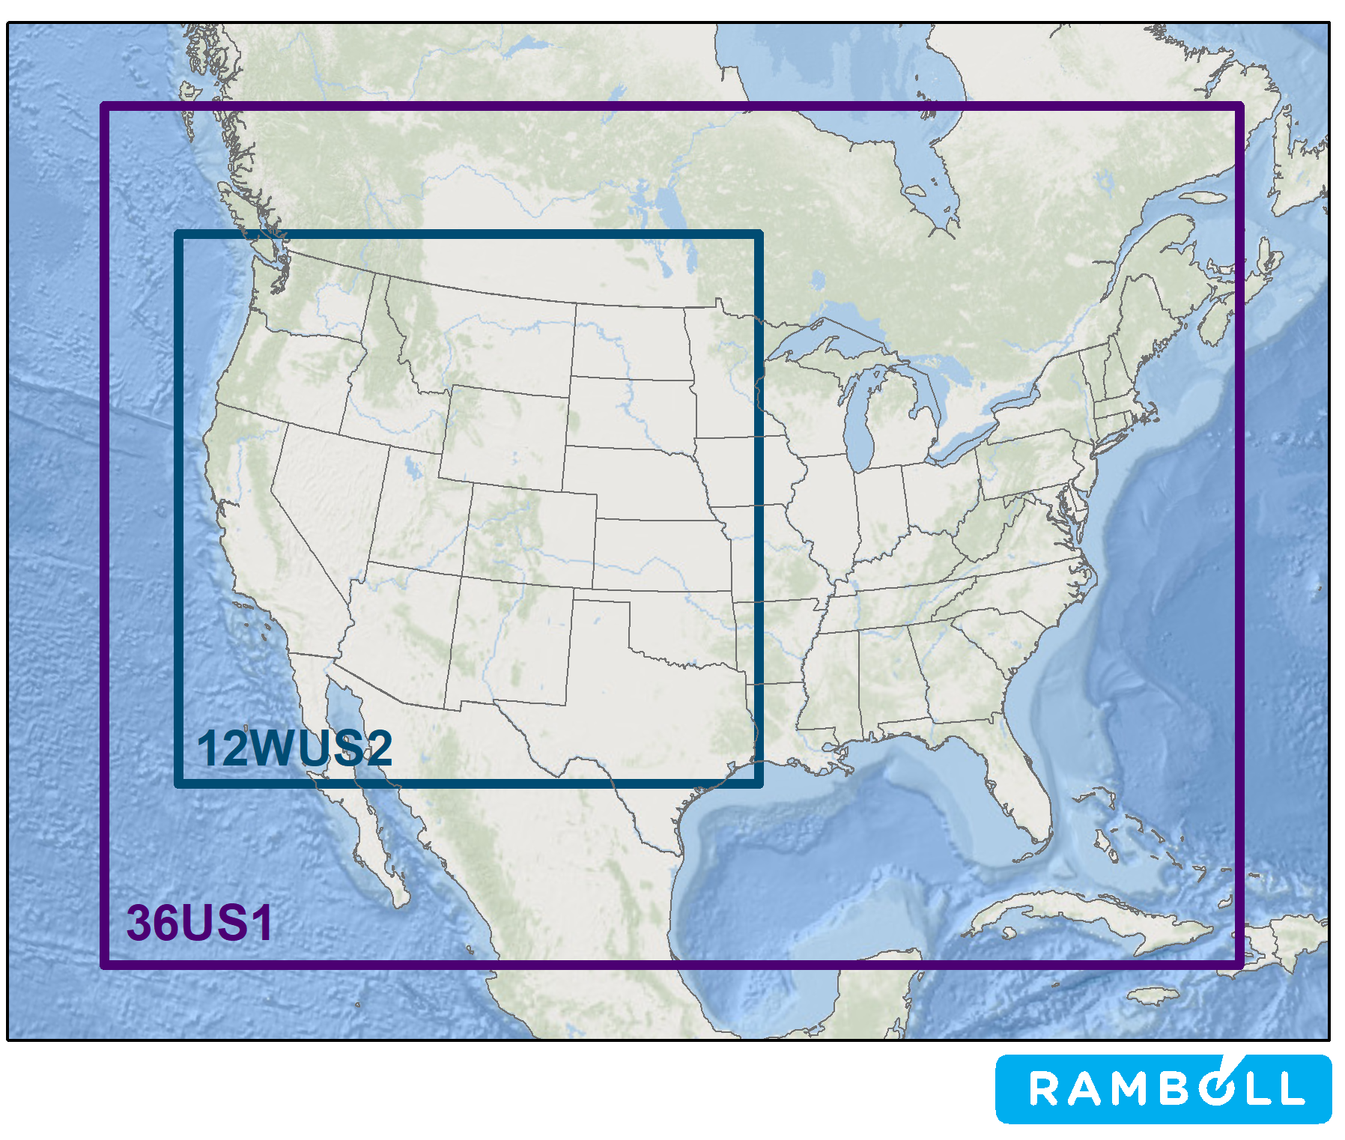

Figure 2. WRAP/WAQS 36/12-km 36US1/12WUS2 modeling domains used in the WRAP 2014 modeling platform current (2014v2 and RepBase) and future (2028OTB) year CAMx simulations.

**POTENTIAL VISIBILITY PROJECTION APPROACHES USING THE WRAP 2014 PLATFORM**

Below we discuss several approaches for using the WRAP 2014 modeling platform CAMx current year and 2028 future year modeling results to project the observed IMPROVE MID visibility impairment for the 2014-2018 5-year planning period to the 2028 future year. The basic projection procedure uses the ratio of the CAMx future (2028) to current year modeling results (i.e., the RRFs) to scale the observed IMPROVE PM species concentration on each IMPROVE MID day from 2014-2018 to 2028, for example:

SO42028 = SO42014-2018 x RRFSO4

Below we discuss several different approaches that can be used to develop the RRF projection scaling factors.

**EPA Recommended Default Visibility Projection Procedures (EPA)**

EPA’s recommended procedure for projecting IMPROVE measured PM species concentrations from the 2014-2018 IMPROVE MID to 2028 uses RRFs based on modeled concentrations from the base year IMPROVE MID, which would be 2014 in this case. The EPA recommended procedures are described in EPA’s 2018 regional haze, ozone and PM2.5 modeling guidance and codified in the SMAT tool. The application of these procedures for the 2014v2 actual base case and 2028OTBb with 2014 actual fires CAMx modeling results is as follows.

1. For each aerosol species (SO4, NO3, EC, OA, Soil and CM),
   1. Calculate Relative Response Factor (RRF) using modeled aerosol concentration:
      1. Use modeling results for the same days in the 2014 IMPROVE MID in 2014v2 Actual and 2028OTBb with 2014v2 fire emissions.
      2. Calculate average model concentrations on MID for 2014v2 and 2028OTBb.
      3. Calculate average RRF for each species average model concentrations.
      4. RRF = 2028OTBb divided by 2014v2.
   2. Apply average RRF for each aerosol species to aerosol concentration for every MID in 5-year period 2012-2016. Define 2028OTB progress for daily MID.
   3. Convert daily concentration to extinction and sum extinction across aerosol species for daily MID aerosol extinction.
2. Convert total extinction to deciview for daily MID.
   1. Average deciview across MID in each of the 5 years.
   2. Average deciview MID across 5 years.
3. Compare Most Impaired Days for 2028OTBb with 2014v2 fire to 2028 point on URP Glidepath.

The EPA recommended visibility projection approach was used to make the 2028 visibility projections using EPA’s 2016 and 2018 CAMx modeling results in their national regional haze modeling discussed above with example presented in Figure 1.

Discussion of EPA’s Recommended Visibility Projection Approach

EPA’s recommended visibility projection approach using RRFs for the 2014 IMPROVE MID could theoretically be appropriate for making 2028 visibility projections using WRAP’s 2014v2/2028OTBb CAMx modeling results that use actual fire emissions. However, it may be inappropriate for use with the RepBase/2028OTBa CAMx modeling results that use RepBase fires. That is because of the RepBase fires are not specific to 2014 so fire concentration impacts could be modeled at IMPROVE monitoring sites on the observed 2014 IMPROVE MID, i.e. on days selected for anthropogenic impairment and more likely to have low natural fire impacts. As the RRFs are supposed to represents the changes in concentrations on the MID, the presence of fires in the RRF numerator and denominator is not only inappropriate but would also make the RRFs stiff (unresponsive to emissions changes) and underestimate the actual improvement in 2028 MID visibility.

The issue of potential RepBase modeled fire impacts on 2014 IMPROVE MID was examined by comparing observed and modeled 2014v2 and RepBase daily PM species light extinction on the 2014 IMPROVE MID. The top panel in Figure 3 shows the observed, 2014v2 and RepBase visibility impairment for the 2014 IMPROVE MID at the CANY1 IMPROVE monitoring site. There are no readily apparent fire impacts, which are indicated by large extinction values due to organic aerosol (also called OMC) and elemental carbon (EC), so the EPA recommended visibility projection approach would not be inappropriate using both the 2014v2 and RepBase modeling results[6]. The lower panel in Figure 3 shows the 2014 MID extinction bar charts for Mount Rainier (MORA1). At MORA1 there are 2014 IMPROVE MID in August that have elevated carbon (attributable to fire impacts) in the RepBase scenario but not in the 2014v2 scenario. Here the EPA projection approach would be not appropriate as the RRFs for OA and EC would be very stiff (i.e., near 1.0). Although fires are most pronounced in the OA and EC concentrations/extinctions, fires also emit SOx and NOx species so would also reduce the effect of any response to reductions in US anthropogenic emissions contributing to AmmSO4 or AmmNO3. The top panel in Figure 4 shows the stacked extinction bar charts on the 2014 IMPROVE MID at Point Reyes (PORE1) IMPROVE site. At PORE1 the 2014v2 CAMx simulations has elevated OA (attributed to fire) on IMPROVE MID on September 11 and 14, 2014 that are not seen in the observed or RepBase modeling results. Thus, the EPA recommended approach may not be appropriate to make projections using the 2014v2/2028OTBb actual 2014 fires CAMx modeling results at PORE1. The bottom panel in Figure 4 show the stacked extinction bar charts for the Lassen Volcanic (LAVO1) site in northern California where the 2014v2 (August 3, 2014) and RepBase (August 24, 2014) CAMx simulations each have one day of elevated OA and EC concentrations (attributed to fire) that would dominate the RRFs using the EPA recommended visibility projection approach.

Figures 3 and 4 confirm that using RepBase fires could result in modeled fire impacts on the 2014 IMPROVE MID that would result in biased RRFs using the EPA recommended visibility projection approach and understate the visibility improvements in 2028. But they also raise new concerns that even using 2014 actual fires in the 2014v2/2028OTBb scenarios there could be modeled fire impacts on the 2014 IMPROVE MID resulting in biased RRFs and 2028 visibility projections.

|  |
| --- |
|  |
|  |
| Figure 3. Stack visibility extinction bar charts for Canyonlands UT (top) and Mount Rainer WA (bottom) IMPROVE sites on 2014 IMPROVE MID for the observed (obs), and modeled 2014v2 actual base case and Representative Baseline (RepBase) emission scenarios using the WRAP 2014 CAMx modeling platform. |

|  |
| --- |
|  |
|  |
| Figure 4. Stack visibility extinction bar charts for Point Reyes CA (top) and Lassen Volcanic National Park CA (bottom) IMPROVE monitors on 2014 IMPROVE MID for the observed (obs), and modeled 2014v2 actual base case and Representative Baseline (RepBase) emission scenarios using the WRAP 2014 CAMx modeling platform. |

**EPA Recommended Visibility Projection Approach Without Fire Impacts (EPAwoF)**

Based on the discussion above, both the 2014v2 and RepBase current year simulations using, respectively, the2014 actual and RepBase fires, can have fire impacts on 2014 IMPROVE MID that would result in biased RRFs and the EPA recommended visibility projection approach underestimating visibility improvements in 2028. Thus, our first alternative 2028 visibility projection approach, which can be used for both the RepBase/2028OTBa and 2014v2/2028OTBb paired CAMx simulations, would develop RRFs based the 2014 IMPROVE MID the same as in the EPA approach, only not using days in which the modeled impacts are obviously influenced by fires. So in the CANY1 example given in Figure 3 above, the Modified EPA projection approach would give the same 2028 visibility projection as the EPA recommended approach as there are no obvious fire impacts. In the LAVO1 example in the bottom panel of Figure 4, the Modified EPA and EPA approaches would give different 2028 visibility projections as the 2014v2/2028OTBb and RepBase/2028OTBa have obvious fire impacts on, respectively, August 3, and 24, that would not be include in the RRFs based on the 2014 IMPROVE MID. “Obvious” fire impacts might be identified using criteria similar to those in the EPA statistical approach for identifying MID in the observed data.

**Modeled MID Visibility Projection Approach**

Another alternative 2028 visibility projection approach to avoid modeled high fire impacts on monitored MID is to base RRFs on the modeled Most Impaired Days (ModMID). PM source apportionment modeling is needed to identify the 20% days in the model simulation that have the highest anthropogenic emissions contribution (i.e., most impaired days). The issue of modeled vs. IMPROVE days with the most anthropogenic impairment was studied in detail using the WAQS 2008 and 2011 modeling databases (e.g., Brewer et al., 2019[7]; Nopmongcol et al., 2016[8]; Morris et al., 2016a[9]; Morris et al., 2016b[10]) that used the results from PM source apportionment modeling to identify the most impaired days, which is discussed in detail on an IWDW website.[11]

WRAP is currently conducting a CAMx Particulate Source Apportionment Technology (PSAT) simulation using the RepBase emissions that will separately the visibility contributions due to fires, natural sources and U.S. and international anthropogenic emissions.[12] From the RepBase PM source apportionment simulation, the 20% modeled days during the year in which the CAMx RepBase has the highest visibility impairment due to U.S. anthropogenic emissions (i.e., modeled most impaired days, or ModMID) can be identified and used in the RRFs. Because fires will be separately tracked in the PSAT simulation, such 20% ModMID can be screened at the outset to eliminate fire contributions. Because IMPROVE measures PM concentrations on a 1:3 day sampling frequency, we envision that RRFs based on the modeled most impaired days would be evaluated using all days (ModMID-ALL) and days with IMPROVE measurements (ModMID-IMP).

**Accounting for Model Performance Evaluation in the Visibility Project Approach (AMPE)**

Any visibility projection approach RRF can be modified to account for model performance evaluation (MPE). In the MPE modified projection approach, days are only included in the RRF if the daily sulfate (SO4) and nitrate (NO3) predicted and observed values are within a certain MPE criteria. If the modeled SO4 or NO3 is not within a specific percentage of the observed value, concentrations on that day would not be used in the RRF. The exact definition(s) of the MPE criteria for which days can be used in the RRFs remains to be determined. Since PGMs generally exhibit more skill in predicting SO4 than NO3, SO4 would likely have a tighter MPE performance criteria than NO3. For example, Emery et al., (2016)[13] listed more stringent Normalized Mean Bias (NMB) performance goals for SO4 (≤±10% and ≤±35%) than for NO3 (≤±15% and ≤±65%). There would also need to be a criterion for minimum number of days to be used in an RRF (e.g., 10 days).

**Summary of Potential 2028 Visibility Projection Approaches**

There are numerous potential approaches for projecting 2028 visibility impairment using the WRAP 2014 RepBase/2028OTBa and 2014v2/2028OTBb CAMx modeling results. This document presented the following approaches:

EPA: Use RRFs based on modeled concentrations on the 2014 IMPROVE MID (i.e., EPA recommended approach that is codified in SMAT).

EPAwoF: Like EPA approach, only don’t use days in the 2014 IMPROVE MID that have obvious modeled fire impacts.

ModMID: Use the modeled days with the most U.S. anthropogenic emissions impairment either from all days (ModMID-ALL) or just days with IMPROVE measurements (ModMID-IMP).

AMPE: Except for ModMID-ALL, the above projection approaches can be adjusted to only use days with a level of SO4 and NO3 model performance (EPA-AMPE, EPAwoF-AMPE, ModMID-IMP-AMPE).

The purpose of laying out potential 2028 visibility projection approaches listed above is not to select an approach at this time, but to facilitate discussion of these and potentially other approaches. When the 2028OTB modeling results become available we will use the alternative projection approaches, which may provide insight into refinements or additional approaches. For example, at this time it is unclear what MPE criteria should be used.

**ADDITIONAL USE OF MODELING RESULTS TO BETTER UNDERSTAND CHANGES IN VISIBILITY IMPAIRMENT AT CIAS**

The IMPROVE MID and the use of the WRAP 2014 modeling platform to project 2028 visibility for the IMPROVE MID represents just a small fraction of the information available from the modeling platform. The EPA visibility projection approach, and variants (e.g., EPAwoF-MPE and ModMID-IMP-MPE) discussed above, use the modeling results for approximately 24[14] days from the annual PGM simulation, which represents approximately 7% of the daily results. Thus, there is a wealth of information in the modeling results on the relationships between emissions and visibility impairment at CIAs that are untapped. WRAP is exploring other approaches, besides just projecting the IMPROVE MID to the future year, so we can better understand the relationship between reductions in U.S. anthropogenic emissions and improvements in visibility impairment at CIAs related to the ultimate goal of the RHR that will be discussed in future documents.

For example, the WRAP 2002 dynamic evaluation CAMx simulation along with the RepBase and 2028 CAMx source apportionment modeling will allow us to estimate the contributions of U.S. anthropogenic emissions to visibility impairment at CIAs for past (2002), current (2014-2018) and future (2028) years that will provide an alternative assessment of whether we are on a path toward no U.S. man-made impairment in 2064. These U.S. impairment results will be available for 365 days a year and the progress can be assessed for more than just the IMPROVE MID, which represents just a small fraction of the number of days in a year (< 10%). The frequency distribution of the changes in sulfate impairment, nitrate impairment etc. from 2002 and 2028 can be analyzed at various impairment levels and accounting for other factors as well.

Also need section on adjusting future projections for Rx fire and international contributions in 2028

1. https://www.epa.gov/visibility/technical-support-document-epas-updated-2028-regional-haze-modeling
2. When EPA performed their national regional haze analysis the 2018 IMPROVE data were not yet available so they used the 4-year 2014-2017 period rather than the 2014-2018 5-year planning period
3. https://www.epa.gov/scram/photochemical-modeling-tools
4. https://www3.epa.gov/ttn/scram/guidance/guide/O3-PM-RH-Modeling_Guidance-2018.pdf
5. https://views.cira.colostate.edu/docs/iwdw/platformdocs/WAQS_2014/Run_Spec_WRAP_2014_Task1-8_Ant-Nat-SA_v5.pdf
6. Note that the large wind blow dust contribution at Canyonlands on 11/1/2014 indicates strong winds that could be associated with atypically large transport of sulfate from Mexico. The model RRF will be insensitive to U.S. emissions reductions if days are included that have large international transport contributions to impairment, and an alternate method to address this concern is to identify the MID based on the days with the largest U.S. contribution to impairment.
7. https://www.tandfonline.com/doi/pdf/10.1080/10962247.2018.1537985?needAccess=true
8. http://views.cira.colostate.edu/wiki/Attachments/Source%20Apportionment/Particulates_v6/C55_Nopmongcol_AWMA_vis_Sep2016.pptx
9. http://views.cira.colostate.edu/wiki/Attachments/Source%20Apportionment/Particulates_v6/RMorris_WRAP_AWMA_Vis_n42_2016-09-29v3.pptx
10. http://views.cira.colostate.edu/wiki/Attachments/Source%20Apportionment/Particulates_v6/RMorris_WRAP_AWMA_Vis_n116_2016-09-28v4.pptx
11. http://views.cira.colostate.edu/wiki/wiki/9152/use-of-particulate-source-apportionment-modeling-to-identify-most-impaired-days
12. https://views.cira.colostate.edu/docs/iwdw/platformdocs/WAQS_2014/Run_Spec_WRAP_2014_Task1-8_Ant-Nat-SA_v5.pdf
13. https://www.tandfonline.com/doi/full/10.1080/10962247.2016.1265027
14. The 20% IMPROVE MID corresponds to 24 days in a year assumed full data capture with IMPROVE’s 1?# day sampling frequency.